Course code/Name: CSA1304 THEORY OF COMPUTATION
Faculty: Dr. Baskar Kasi
Name: S. Harish
Reg. No: 192511119

- Write a C program to simulate a Deterministic Finite Automata (DFA) for the given
language representing strings that start with a and end with a.
PROGRAM:
#include<stdio.h>
#include<string.h>
int main(){
char str[100];
int n,i;
printf("Enter a string:");
scanf("%s",&str);
n=strlen(str);
if(str[0]=='a'&&str[n-1]=='b')
printf("The given string is accepted");
else
printf("the given string is not accepted");
return 0;
}

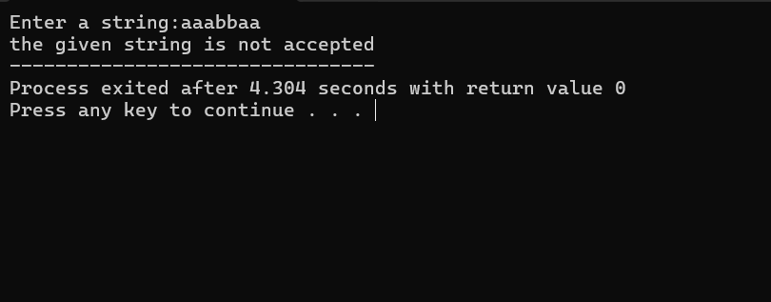
OUTPUT:

